[Utility Logo]

URGENT

IMPORTANT HEALTH NOTICE

[Water System Name] has finished replacing the lead piping from the water service line that we own (from the watermain to your property line) with a [copper] service line. We wanted to alert you that lead may have been released into your water during construction. Even if you have removed your portion of the lead service line, lead particles can remain in the pipes even after we complete our flushing and can cause a temporary increase in lead levels at the tap. .
Lead exposure has been associated with effects on intellectual development and behaviour of children. Other health effects, such as cardiovascular effects (increases in blood pressure and reduced kidney function) have also been associated with relatively low levels of lead exposure.
To minimize your exposure to any trapped lead particles, you must flush all your faucets as soon as possible, following the steps below:
- Remove faucet aerators from all cold water taps in the home (see instructions below).
- Starting at the lowest level of your home, and making your way to the top level, fully open ALL cold water taps (including any outside taps, bathtubs and showers).
- Let the water run for at least 30 minutes, timing from the last tap you opened (top level).
- Turn off each tap starting with the taps at the top level of the home.
Until flushing is complete, do not consume the tap water or use it to make infant formula, and do not use hot water, icemakers, or filtered water dispensers. After flushing, increased lead in drinking water levels still continue for several weeks (or longer if only our portion of the lead service line is replaced). To reduce your exposure to lead particles during this period:
- Do not use the tap water to make infant formula.
- Always use cold, flushed water for drinking and cooking.
- Use alternate water (e.g., bottles) or install a home filter on taps used for drinking and cooking, especially if you have children or are pregnant. Filters can either be mounted directly on the tap or may be pour-through, pitcher-type devices that sit on the countertop. These filters can be purchased at local hardware stores, department stores or online. Please verify that the filter is certified for lead removal by NSF International or another recognized certification body.
- You may wish to test your water for lead before resuming regular use. Lead in Drinking Water: Information for Manitoba Homeowners and Home-based Child Care Providers (gov.mb.ca)
For more information, please contact:
[Utility Name] Project Manager: [Project manager’s name]
24-Hour Customer Service Line: [customer service line number]
More information about lead in service lines can be found under the header [website header] on our website at: [website]
Faucet Aerators (also called screens)

Routinely clean faucet screens. Sediment and metals can collect in the faucet screen located at the tip of your faucets. Replace screens that are in poor condition. New screens are available at local hardware stores.

To clear the faucet screen of debris:

- Unscrew the screen (see picture below).
- Separate the individual parts.
- Remove any sediment (mineral or rust buildup) on the screen and other parts. If necessary, soak the parts in white vinegar for a few minutes and scrub with a brush.
- Replace the rubber washer as needed.
- Reassemble the screen parts and reattach to faucet.

- Repeat process for all household faucets. All faucets should have an aerator unless you have a faucet-mount filter installed at the tap.

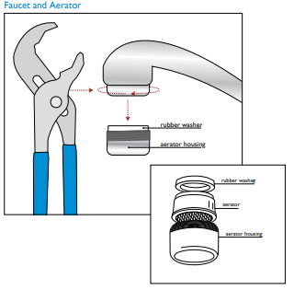

Modified from DC Water, https://www.dcwater.com/sites/default/files/household_water_quality.pdf

